Customizing your Starfish profile

Slide # | script | Image / call out
 | Music fade in and out | Starfish and MSU logos?
 | Hi there, this is Chris Gonnella. Welcome to this brief tutorial on customizing your Starfish profile. | Photo of me
 | As an instructor or advisor at MSU, one of the first things you should do in Starfish is update your profile.  When students find you in Starfish, your profile information is displayed for them when they hover over your name. <display my profile shot >  Students who recognize your face are more likely to reach out for help. So, we highly recommend that you upload a photo of yourself to your profile.  In this video, we will focus on a few simple updates that will help students connect with you. | 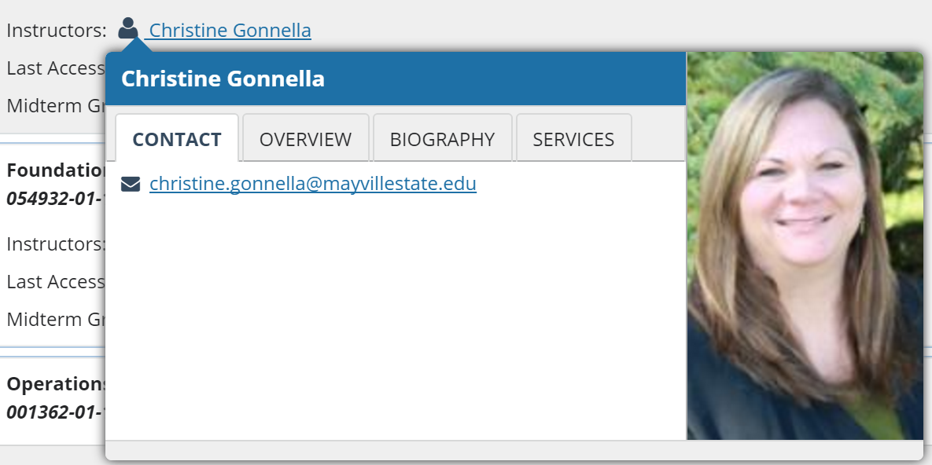  Orange Rectangle Call out  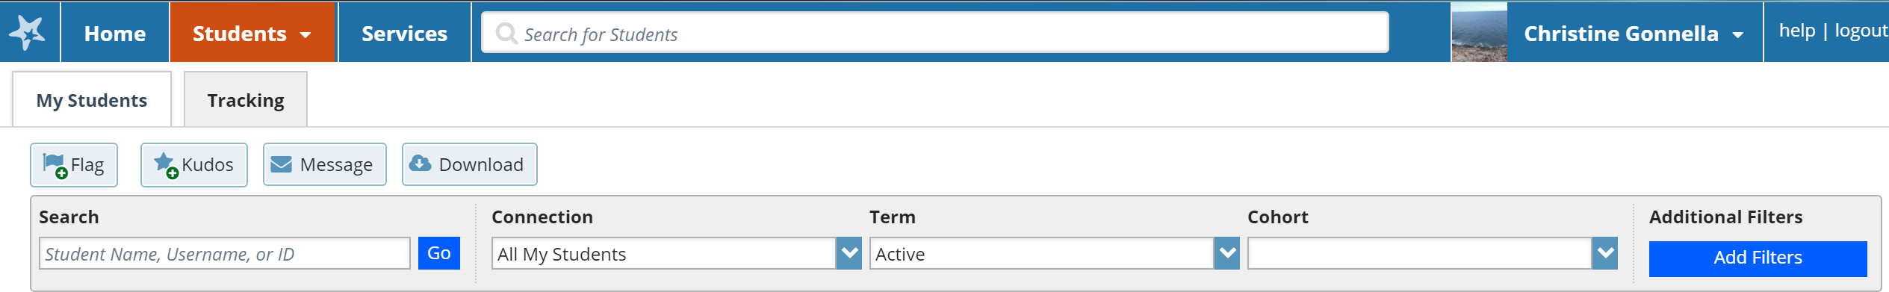
 | Open your profile by clicking your name at the top right of the screen.  Your username, institution email address and local time zone should already be imported from Connect ND. | Blue square call out  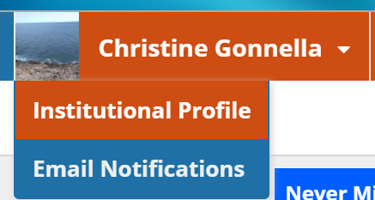
 | To upload a photo, click the upload photo link that is located under the placeholder image on the left of the screen
 | Browse your computer for a photo, then click the upload now button
 | Let’s take alook at the Contact information area, which has several fields. | 2 blue Rectangular callouts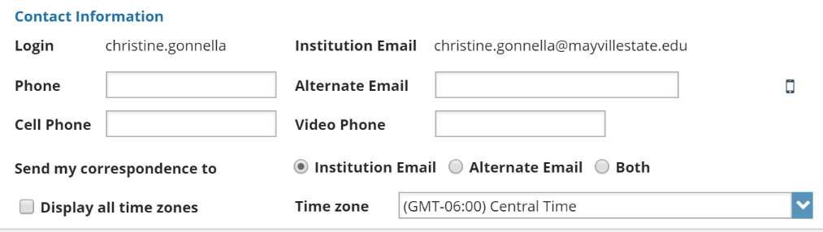
In the Phone section, enter your office phone number. If you do not have an office on-campus, enter the number you use to communicate with students.

If you would like to provide students with your cell phone number, feel free to do so in the Cell Phone field.

 | In the Alternate Email field you can either:  - enter an email address other than your institution email, such as a gmail account;  - enter a mobile phone email address which will send notifications to your mobile phone.  <zoom in on cell phone icon> Click the Cell Phone icon to find the format of the mobile phone email address based on your cellular provider. | <Add a link to the cell phone icon?>  Zoom in on the cell phone icon
 | For example, Verizon uses vtext.com for their email domain. So if you use Verizon, you would enter your phone number – using only numbers – and add “@vtext.com”.  Doing this means that any time you choose to be notified in Starfish, you can also choose to receive that notification via text. | 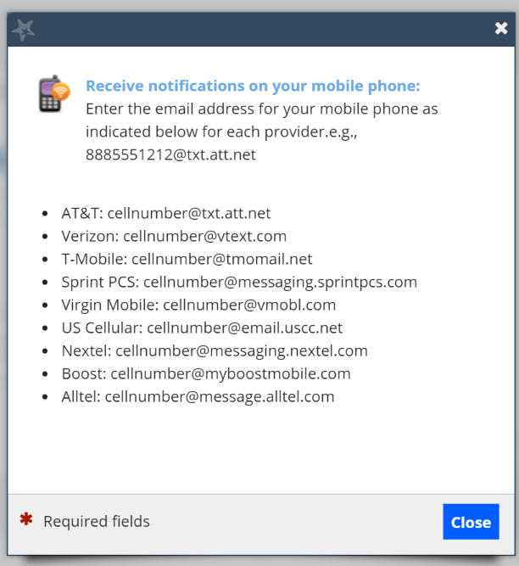
If you would like to work with students using video phone, such as Skype, enter your ID in this field.

For example, if you do use Skype, you could include that in what you enter here.
 | Starfish gives you the option of receiving your correspondence through your institution email, your alternate email, or both.
The Time Zone section is pre-populated, but you can choose to change it if you wish. This may come in handy when you are out of your usual time zone.

You can also choose to display all time zones. This may be helpful when you have students who reside in time zones that are different from yours.
 | When you are done making changes to your profile, <Zoom in on Submit button> click the Submit button on the lower right corner of the screen.
 | We have now reviewed all the information you need regarding customizing your profile. If you have any questions, please feel free to contact someone on our Starfish Implementation Team. | List of people on the implementation team.  Fade in music
 | Fade out music | Starfish and MSU logos?

